Project Design Phase-II
Solution Requirements (Functional & Non-functional)

Date | 31 January 2026
Team ID | NEHAL YADAV
Project Name | FORMULA 1 Race Intelligence Dashboard Analysis Report 2010-2026
Maximum Marks | 4 Marks
Functional Requirements:
Following are the functional requirements of the proposed solution.
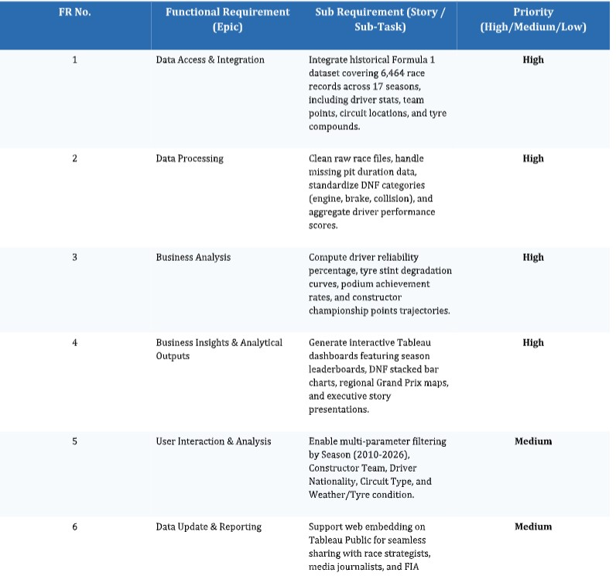

Non-functional Requirements:
Following are the non-functional requirements of the proposed solution.

